Paper Puzzles

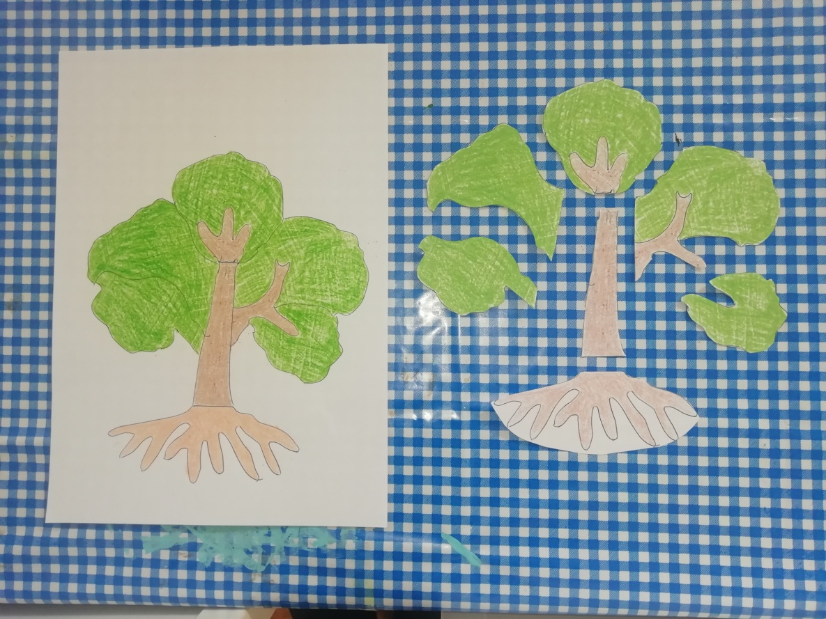

- These puzzles are activity 2 in a series of 4 activities used for introducing Zoology and Botany subjects to children. Activity 1 is the real experience – take your child outside and study a real tree (or a bird or fish etc depending on which subject matter you are looking at). Activity 2 is these parts puzzles. Activity 3 is the pairing cards (also on the resources page). Activity 4 is the 3 part cards, on the resources page.
- Print 2 copies of each puzzle
- Cut one into pieces as demonstrated in the picture. This must just be done so that the component parts are as separate as possible.
- If it is possible to stick these to cardboard (cereal packets are ideal) or laminate them they will last longer.
- Use the whole picture as the control puzzle for your child to build the separate pieces on top of.
- Demonstrate to your child how to do this, by carefully studying the whole tree, and then very obviously studying the parts and choosing the correct one to then place on top of the corresponding part of the control map.
- Once your child has grasped the concept of piecing the puzzle together you can name the parts if desired although this is not the main objective here.
- You can also suggest your child builds the tree next to the control map once they have practiced building it on top of the control map a few times, and then progress to doing it without the control map.

