Colour Box 3
Grading
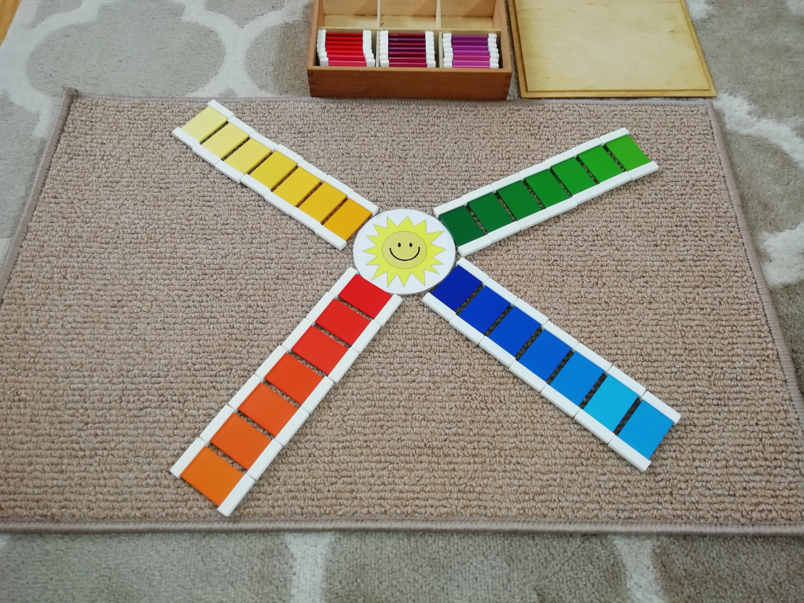
- You will need the colour grading printout and have cut each colour into separate tablets. Sticking the paper to card means the activity will last longer. A plain piece of paper for grading onto and a sun to grade around.
- Invite your child to try this activity.
- If you have done previous colour work remind your child of the work you have done with colour matching initially with three colours and then more. Explain that we are going to do something different with colours with this activity.
- Explain that we are going to grade the colours, which means to put them in order from darkest to lightest and that we will work with one colour at a time.
- Ask your child to choose one colour to grade.
- Place your sun on the mat or table that you are working on for your child to place the graded colours around as shown in the picture.
- You will need one piece of plain white paper to do this on.
- Ask your child to lay all of the shades of one colour out along the piece of paper.
- Ask which your child thinks is the darkest. Hopefully they will choose the darkest. Ask which they think is the lightest. If they point to the lightest you know they understand the concept and should be ready for this activity. Show them how to place the darkest tablet closest to the sun.
- Ask your child to choose the darkest colour now from those remaining on the piece of paper. Place this next to the first one, working outwards from the sun in a row.
- Keep doing this until all the shades of one colour have been graded in one row outwards from your sun.
- Go back to the darkest shade closest to the sun and explain to your child that we graded from the darkest shade (pointing to the darkest shade) and that the colour got lighter (point to the next shade) and lighter, and lighter (you are pointing to each shade tablet in turn) until you get to the lightest. Label it as the lightest. You have now introduced your child to the grading language required for this activity. You can also start with the lightest and point to each in turn saying, lightest, darker, darker, darker, darkest.
- If your child successfully graded the first colour allow them to choose another colour and keep going until either they get fed up and want to finish or until they have graded all of the colours.
- This is quite a long activity so your child may not want to grade all of the colours the first time.
- If your child is struggling to grade try doing the activity with just three shades from each colour but make sure they are very contrasting shades, so obviously very different. Use the darkest, the lightest and the middle shade. If they can do this allow them to do the activity a few times with just three shades from each colour graded around the sun.
- If they cannot point to the darkest and lightest, they are not ready for this activity. Spend some time looking for dark and light shades of colours in your environment and labeling them as dark and light and then try this activity again but start with the three shades of each colour as explained above.

