Pairing Cards
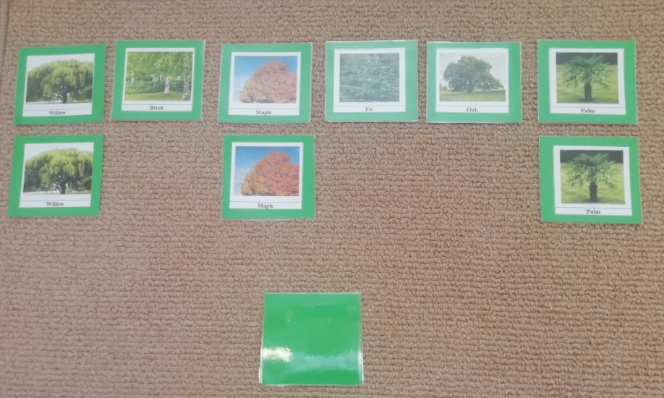
Tree Pairing Cards
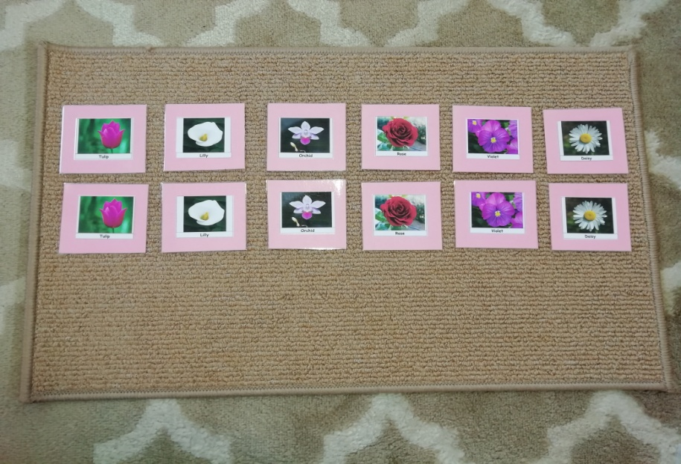
Flower Pairing Cards

The pairing cards are from the culture curriculum area and are used in Botany and Zoology as part of a 4 part series of activities that introduce a child to a subject matter. The pairing cards are the third activity in the series and are used to further classify a subject, for example trees, by looking at different kinds of trees. Although this is a culture activity it aids children with visual matching and increases vocabulary and conversation skills.
- Invite your child to try this activity.
- Explain that the activity is looking at trees but in a different way than in previous activities. (If you have done the first two activities in the series being the real experience and the paper puzzle, both of which just looked at one tree).
- This activity is best performed on a mat on the floor.
- The cards should be separated in to two sets before you begin.
- Take the first set and lay them out horizontally across the mat – do not name the trees yet.
- Take the second set of cards and put them in a pile face down underneath the first set of cards.
- Turn the first card over in the face down pile and very obviously look for a visual match, compare it to each of the top row of cards before finding a match.
- Do the same with the second card in the pile.
- Offer for your child to turn over the third card and try to match.
- If they are able to let them match the remaining cards.
- Ask if they want to do it again – often they will want to.
- Allow your child to set out the top set of cards with a little direction if needed.
- Allow them to match all of the cards – hopefully unaided.
- With subsequent practices you can introduce the tree names each time a child turns the cards over to match to the top set just give them the tree name.
- Once your child has mastered the visual matching this activity can become about naming the trees and discussing them. Has your child seen all the types of trees? How are they all different? Are they all found in your country?
- This activity can be extended by using all of the cards turned over face down on the mat and used as a traditional memory matching game with 2 or more people. Each person can only turn over 2 cards at a time and has to try and find matching pairs, remembering where they have seen each card. Every time a card is turned over see if your child can name the tree, if not give them the name.

